Meeting Notes
OSCC Board
February 20, 2025
Present: Brian Low, Joanne Barber, Bill Smith, Jim Porteous (virtual), Trevor Stokes, John Brown
Regrets: Willard VanderPloeg, Jane Lemon
Call to Order: Brian welcomed everyone and called the meeting to order.
Website: Trevor continuing to update website. Discussion took place with respect to information on registration. Health information will be deleted in future. The rider is responsible to notify ride leader of any health concern. Registration page updated.
Brian will ask Melinda to complete her bio and picture on Leadership page
Jim has updated his profile bio on Leadership page.
Discussion and steps have taken place to have director access only pages where minutes, finance, reports, etc., may be stored on the website to avoid loss of documents over time. Trevor has begun the process.
Financial: John provided updated financials and discussed costs to be included for 2025 budget. Following the meeting, the information copied below was provided:
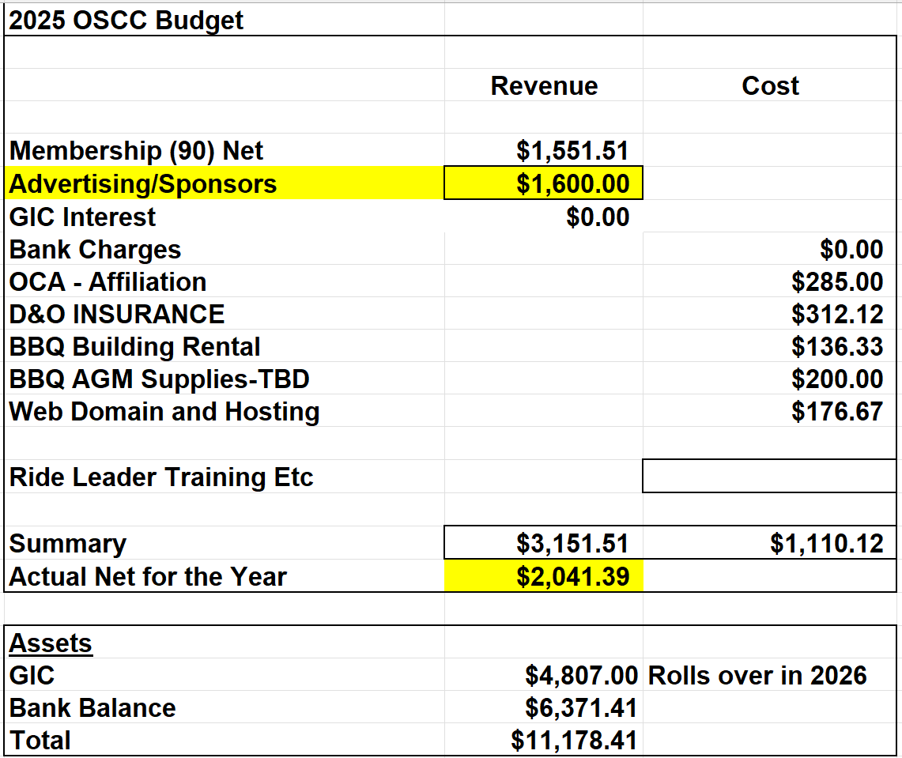
The financials do not include the sale of any clothing from the $1,600 inventory which will add to the revenue. Ride Leader expenses need to be added.
Strategic Planning: The process will begin fresh as information from first session is not available.
Thanks to Sponsors: Year end is March 31. Bill will complete thank you’s and solicitation to complete the process and have sponsor information on website and Facebook at that time.
OC Membership: Club membership is complete and now all registration information is on the website and open to members.
The website includes updated information on type of membership and optional insurance. An eBlast will also be sent to members and information posted on the website.
OC has been requested to provide information on how membership category and insurance coverage may be changed with this new information provided.
CR#1: Brian has been in communication with Lloyd Lewis and will pursue to discuss ways to work together. Progress has been seen on County consideration: https://www.owensoundsuntimes.com/news/local-news/grey-county-seeks-road-funding
Brian will also contact Steve Jarvis with respect to his offer to analyse Strava information on road traffic.
Facebook/Newsletter: The Facebook group has been set up. Jane has indicated that she would prefer not to be social media coordinator. (my notes unclear as to whether anyone else was interested?)
Aiden Ware removed from Facebook administration.
Jane will be in touch with Tom Hakala to discuss work on OSCC newsletter and considering taking on the role as editor.
Ride
Coordinator: Ride leader appreciation night was held at the Smith’s with Melinda and Bill hosting. A good turnout was there and lots of great discussion and camaraderie present.
Melinda will be preparing the ride program and training plan over the next month or so.

New Business: Joanne provided a brief re the women’s self-supported Manitoulin trip. A description will be shared with Melinda and Brian and consideration of this as a sanctioned ride for OSCC members.
Time Trials were discussed. Joanne spoke to Todd Wainwright and was told a number of triathlon athletes would be interested in TT’s. No information was gathered with respect to these athletes taking out OSCC memberships, or to taking on admin responsibilities. Joanne to follow up.
Next Meeting: March 20, 2025 – 12:00 noon in the Library Boardroom – to be confirmed.

