OSCC Ride Captain’s Web Guide

Prepared by
Trevor Stokes

Date
2024-01-11

Revised
T. Stokes 2024-01-18
T. Stokes 2024-04-24
T. Stokes 2024-04-30
T. Stokes 2024-06-07
T. Stokes 2024-08-22
T. Stokes 2024-04-16

Table of Contents
OSCC Ride Captain’s Web Guide 1
1 Introduction 3
2 Logging In 3
3 The Events Dashboard 4
3.1 Events 5
3.2 Add New 5
3.3 Tags 5
3.4 Event Categories 5
3.5 Venues 5
3.6 Organizers 5
3.7 Import 6
3.8 Settings 6
4 Create a New Ride 6
4.1 Title 6
4.2 Long description 6
4.3 Event Status 7
4.4 The Events Calendar 7
4.4.1 Time and Date 7
4.4.2 Location 7
4.4.3 Organizer 7
4.5 Excerpt 7
4.6 Author 7
4.7 Event Category 7
4.8 Publish 8
5 Edit a Ride 8
6 Embed a Strava Route 9
7 Embed a Garmin Route 10
8 Link to Sign-up Sheet 11
9 What the Member Sees 11
10 Revision History 12

Introduction
A free plugin was installed on the Owen Sound Cycling Club’s website to help manage the setting up and display of club rides and other events.
This guide assumes the ride captain has an account on the website and can login and use the website’s dashboard.

The plugin was originally intended for concerts, etc. Some of the terminology reflects that.
The guide will take the ride captain through the steps of creating “Venues” (meeting locations) “Organizers” (ride captains and leaders) and “Events” (rides).

The instructions apply to a desktop computer. On smaller devices menus may look different.

Logging In

Type the website’s address, www.owensoundcycling.ca, in the browser’s address field.
At the foot of every page there is a log in link – click that and enter your username or Email Address and password. If this is the first ever login, proceed as for “Lost your password?” to set one.

You will be taken to the dashboard. You can also reach the dashboard if you’ve navigated away by hovering the mouse of the site’s title, top-left, and choosing Dashboard.

Note:
You must have an Editor or higher user role to add and edit events. Also, although a WooCommerce Shop Manager is based on the Edit role, it does not allow adding and editing events.

The Events Dashboard

If you hover the mouse over Events the submenu will appear.

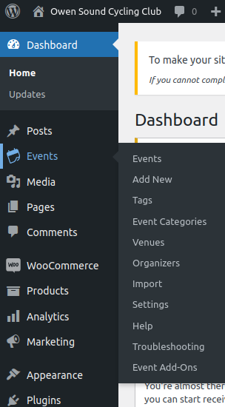

Events

This lists all current events. Individual or a range of events can be viewed, edited or deleted.

Add New

This takes you directly to an empty form for creating a new event.

Tags

Tags can be created and listed on this page.

Event Categories

The webmaster has created a list of potential categories. E.g. Breakfast, Co-Ed, Virtual. You will reference one or more of theses when setting up a ride. You can assign multiple categories to an event. E.g. Road, Daytime and Co-ed. Others can be added if needed.
The website is able to filter rides by category.

Venues

These are meeting places for rides. If an accurate address is entered, the website will include a Google map of the location. All of our regular meeting places should be listed already. More can be added as needed.
A given Venue is defined once and can be referenced by many Events. If the title or address of a Venue is subsequently changed, the change will appear in every existing, past or future, Event.

Organizers

These are the ride captains and leaders. Most of our regular captains will have been added by the webmaster. More can be added as needed.
Ride captain or leader names (Organizers) are defined once and can be referenced by many Events.

Import

We can fill the calendar at the beginning of the season by uploading a CSV file. This could set up the basics, leaving the exact route and ride captain to be added closer to the date.

Settings

These are for use by the webmaster.

Create a New Ride

The logged in ride captain navigates to Dashboard / Events / Add New.

Note: Some items may have been moved up or down or dragged to the right hand side. Some may have been collapsed. Be sure to make an item visible by clicking the triangle.

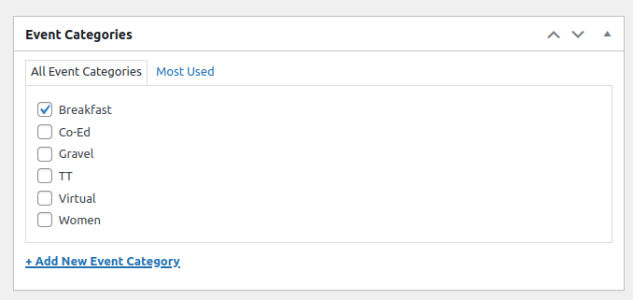

Title
Give the ride a title. Be consistent, but do not include the date.

Long description
Use the visual editor to enter details of the ride. This could include images. If you have used the import utility and it’s the same for all, the long description may already be there. Modify for the specific ride if necessary.

OSCC has developed a WordPress short code to embed details and an image of a Strava Route. See 6 for details.

At season begin the ride captain will setup the sign-up sheets for all of the season’s rides, all categories. A link to the sign-up sheet, and the exact tab can be added to the description. See 8

Event Status
This defaults to Scheduled. If the ride is canceled or postponed you can revisit this by editing the ride.

The Events Calendar

Time and Date
Enter the date, start time and approximate end time.
Note: this plugin does not manage recurring events. But we can import a range of events.

Location
Choose the meeting place for the ride. All of the regular locations should be listed. If not, a new one can added. See 3.5
Leave Show map and Show map link checked. The system will include the familiar Google Maps thumbnail image.

Organizer
Choose the ride captain for the ride. All regular ride captains and leaders should be listed. If not, a new one can added.
After one organizer has been added a button Add another organizer appears. Click that if there are multiple captains / leaders.

Excerpt
Enter a short description of the ride. This will appear when the rides are listed in the calendar view.

Author
This control should have chosen the logged on ride captain.

Event Category
IMPORTANT: Don’t forget to choose at least one category. In the website rides can be filtered to list only one category. E.g. Women.

Publish

Preview changes if necessary and finally Publish.

Edit a Ride

Navigate to Dashboard / Events /Events. Hover over the event to change and select edit.
Or, if you are viewing a ride (event) in the website “Edit Event” appears in the status bar. Click that. Both methods take you to the editor.

You can change any of the properties that were specified when the event was created.
For example, the start location or ride captain can be changed by selecting them from a drop down.

Preview changes if necessary and finally Update.

Embed a Strava Route

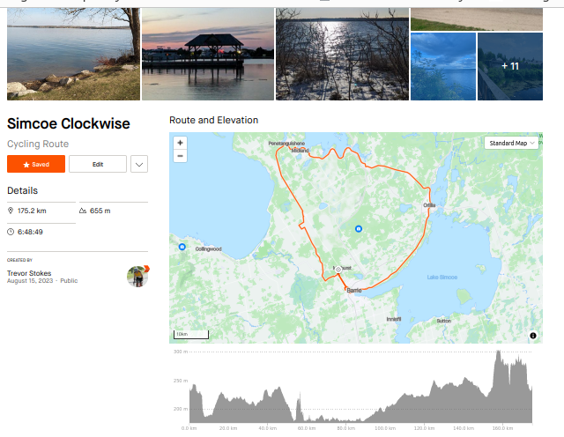
On Strava’s website find a route you want to embed.

Something like this will be in the browser’s address field.
https://www.strava.com/routes/3126580325001195576

Copy the number (Route ID) to the clip board.

On any webpage, or in the long description of a ride, enter…

[embed_route route_id=3126580325001195576 type=strava]

where the route_id is the pasted numeric string from Strava. Type is optional and defaults to Strava. The square brackets are required. A similar image, zoom-able and with working links, is embedded in the page or event.
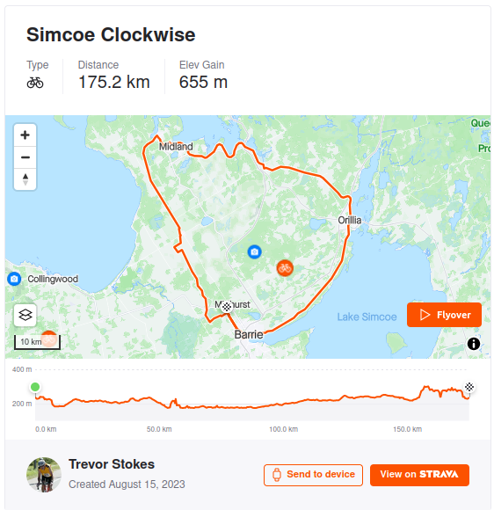

Embed a Garmin Route

Similar to Strava, you can now embed a Garmin route.
Find the route on Garmin Connect. It will look like this in the browser address field.

https://connect.garmin.com/modern/course/128842184

Copy the number (Route ID) to the clip board.

On any webpage, or in the long description of a ride, enter…

[embed_route route_id=128842184 type=garmin link=y|n]

where the route_id is the pasted numeric string from Garmin.
type must be garmin.
link=y will produce a direct link to the route on Garmin’s site. It defaults to no link if omitted.

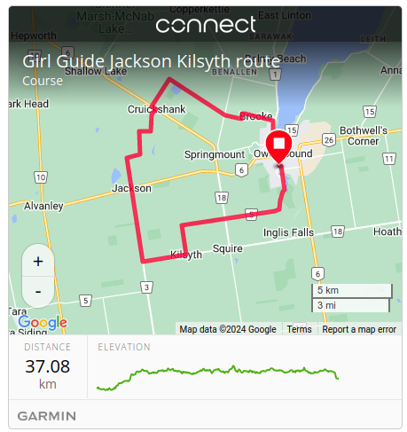

Link to Sign-up Sheet

The club uses Google spreadsheets for ride sign-ups. This has a long address.
Navigate to the Google address and then select the appropriate sheet (tabs along the bottom – Breakfast, Monday Mixed, etc.) and copy the entire address from the browser’s address field.
Edit the event. Type, for example….
Click here to sign up.
Hi-lite the word here and click on the chain link icon or press (Ctrl+k). Paste in the entire Google address and apply.

For a different category of ride, simply select a different sheet. The last digits of the address will be different for each sheet.

What the Member Sees

From the navigation menu, and possibly from other pages, there is a link to Calendar.

This brings up a list of the next few rides. The member can choose to change this to a Month or Day view.
Events can be searched for. Categories and tags can be used for the search.
At the end of the list is a “Subscribe to calendar” button to synch the website’s calendar with the member’s.

When an event’s title is clicked, a full page view of the ride appears. This will include…

- The Title.
- Date and time.
- The long description complete with any media, the embedded Strava route, if there is one.
- An “Add to calendar” button. The member can add this event to their personal calendar.
- More detailed date, time start and end.
- The category. This is a link, which, if clicked, brings up a list of future events for only that category.
- The location address and a Google map of the location.

Revision History
2024-01-11 | T. Stokes | - Original
2024-01-18 | T. Stokes | - Minor typos corrected.  - Multiple ride captains and leaders.
2024-04-24 | T. Stokes | - Note on Shop Manager user role.
2024-04-30 | T. Stokes | - Added support for Garmin embed route.
2024-06-07 | T. Stokes | - Clarified the relationship between Venue and Event.  - Change cross-refs from Page No. to Section/Paragraph.
2024-08-22 | T. Stokes | - Multiple categories  - Embed Garmin – option to produce a link to route.
2024-04-16 | T. Stokes | - Changed ride leader to ride captain where appropriate.  - Renamed document.

